INFRASTRUCTURE INVESTMENT OPPORTUNITY IN THE REPUBLIC OF AZERBAIJAN

REHABILITATION OF THE HOVSAN AERATION WASTEWATER TREATMENT PLANT
AND INSTALLATION OF NEW WASTEWATER RECYCLING FACILITIES

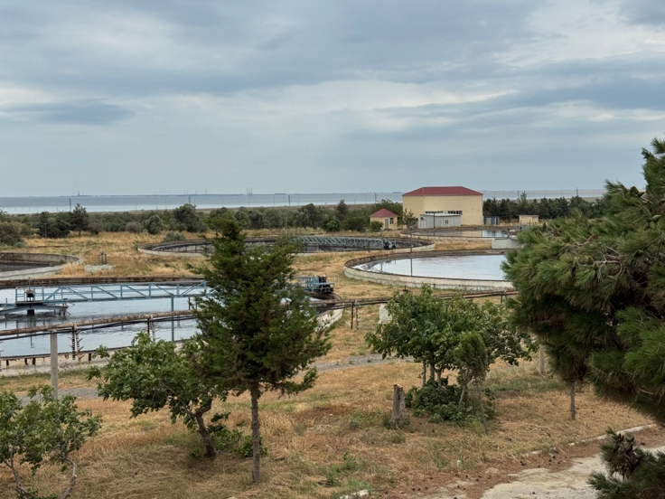
Disclaimer

This teaser (“Teaser”) has been prepared by the Azerbaijan State Water Resources Agency (“ASWRA”) and the Ministry of Economy of the Republic of Azerbaijan (“MOE”) (collectively, ASWRA and MOE are hereinafter referred to as “Procurement Authorities”) for the specific purpose of providing preliminary information regarding an investment opportunity to the private market. Any recipient of the Teaser (“Recipient” or collectively “Recipients”) should undertake its own independent investigations and due diligence and should not rely solely on the information, assumptions or projections contained herein.
For the avoidance of doubt, no representation, warranty or undertaking (express or implied) is made to any Recipient as to the adequacy, completeness or accuracy of the information in respect of (a) the validity or appropriateness of the assumptions on which the information is based or (b) the reasonableness of any projections.
Procurement Authorities accept no duty of care to any person, and to the extent permitted by law, Procurement Authorities accept no liability of any kind and disclaims all responsibility for the consequences of any third party and/or any Recipient using or being unable to use the Teaser or information or acting or refraining from acting in reliance on the Information.

Procurement Authorities and Decisions by the Government of Azerbaijan

- MOE is the central executive authority responsible for implementing state policy and regulation in various economic areas, including public-private partnerships (“PPPs”) for infrastructure development in the Republic of Azerbaijan (“Republic”) as per the national legislations including the Public-Private Partnership Law (No.691-VIQ) dated 9 December 2022 as amended.

- MOE promotes the growth and development of the water supply and sanitation (“WSS”) sector in the Republic by providing technical and financial support to WSS projects and coordinating with international organizations to access financing and technical assistance for the WSS sector. MOE works with other central executive authorities, including the ASWRA, to coordinate efforts and ensure that the nation’s WSS systems are developed and operated consistently with the overall economic goals of the Republic.

- ASWRA is the central executive authority for the management and protection of water resources in the Republic. ASWRA oversees formulating the Republic’s water policy, ensuring its implementation, fulfilling water-related economic regulatory functions, fostering sector coordination, and supporting overall development of the WSS sector. Furthermore, ASWRA is tasked with ensuring water security, developing master plans for water resource use, improving water service efficiency and quality, and defining investment priorities for the WSS projects in the Republic.

- ASWRA intends to prepare and implement the project for the rehabilitation of the Hovsan aeration wastewater treatment plant and the installation of new wastewater recycling facilities (“Project”) as per (i) the Presidential Order No.4229, dated 25 December 2023, titled “On measures for the implementation of a pilot project on the treatment and reuse of wastewater discharged from the Hovsan aeration plant into the Caspian Sea”; and (ii) the Cabinet of Ministers Order No.1020s, dated 28 December 2023, titled “On ensuring the implementation of the Order No. 4229 of the President of the Republic of Azerbaijan”.

- MOE published a list of PPP projects for implementation in 2026 as endorsed by the Cabinet of Ministers Order No. 420s, dated 11 July 2025, titled “On approval of the List of Public-Private Partnership Projects for 2026”, where ASWRA was nominated as the public partner for the Project’s implementation under PPP modality.

- The Cabinet of Ministers of the Republic acting through the Water Commission endorsed on 25 June 2026 the Project’s implementation through PPP modality and the selection of a Private Partner through a competitive tender process. Asian Development Bank acts as the Transaction Advisor throughout the project preparation and tender process.

National Water Sector Strategy and Priority

- Water stress is a critical impediment to sustainable development in the Republic. Impact of climate change and high reliance of the nation’s economy on volatile transboundary water sources exacerbate the challenge.

- The Government of Azerbaijan (“GOA”) aims to enhance water management and address water scarcity as per the “National Strategy for Efficient Use of Water Resources (October 2024)”.

- The national strategy promotes the construction of new reservoirs, the development of smart water management systems, the prevention of pollution, and the increased use of desalination and recycled water as alternative water sources.

- The Greater Baku metropolitan area has a population of approximately 2.5 million, with around 52% connected to the sewerage network, although only around 60% of collected wastewater currently receives treatment before discharge.

- Under the Presidential Order No. 883, dated 12 January 2026, approving the "State Program for the Improvement of Water Supply, Stormwater and Wastewater Systems in the City of Baku and the Absheron Peninsula for 2026–2035", the reconstruction of existing wastewater and stormwater collectors and the 12 new wastewater collectors with a total length of 345.6 km are planned. These measures will expand the coverage of the wastewater network and ensure the separation of stormwater from wastewater, preventing their intermixing.

- The Hovsan aeration wastewater treatment plant (“Hovsan WWTP”) is the largest wastewater treatment plant in the Republic. It serves the capital region as a strategic infrastructure to support the nation’s sustainable economic and social development.

- GOA has identified the rehabilitation of the Hovsan WWTP as a national priority to improve wastewater treatment, expand water reuse, and strengthen the country's water resilience.

- The Project is expected to contribute to the Republic in addressing key challenges and strategic objectives:

- Environmental Sustainability. Current pollution loadings from discharge of the Hovsan WWTP into the Hovsan Bay exceed environmental standards, which has resulted in increased pollution of the bay as evidenced by eutrophication, bacteriological indicators and increased mineralization. Rehabilitation of the Hovsan WWTP will significantly reduce pollutant loads to the Caspian Sea.

- Efficient Water Management. Key industries in the Republic rely on limited and costly water supply, which restricts its economic potential. For example, the nation’s agriculture industry builds on irrigation (>70%), of which productivity is constrained by the water scarcity. In Absheron area, there are more than 5,000 hectares of agricultural lands within 25 kilometres of the Hovsan WWTP, which can be an efficient supply source of alternative water to those lands for significant benefits. Such benefits include, among others, (i) reduced operation and maintenance costs for the Absheron Canal, (ii) economic benefits from increased agricultural production and employment, and (iii) reduced stress on existing potable water supplies.

Project Scope and Asset Information

- The Project’s scope includes (i) the rehabilitation, financing, operation and maintenance of the Hovsan WWTP (design capacity of 640,000 m³/day) and (ii) the design, construction, financing, operation and maintenance of a new 100,000 m³/day wastewater recycling facility for supplying recycled water to agricultural users.

- Land for the Project is available and secured within the existing footprint of the wastewater treatment facility (approximately 112 hectares in total) with established site boundaries, existing utility connection, and significant space for future expansions.

- The recycled water transmission pipeline and the sea outfall pipeline for effluent discharge are outside the scope of the Project as those will be developed and managed separately by ASWRA.

- Constructed during the Soviet era in the 1980s, the Hovsan WWTP is located approximately 15-kilometres East of the capital city of Baku and approximately 1-kilometer North from the Caspian Sea shore. (https://maps.app.goo.gl/wr6TrrhzwHSVpiSs9)

- Although portions of the Hovsan WWTP were upgraded in Y2009 with minor rehabilitations in Y2014, the wastewater treatment facility is not providing adequate pollutant removal due to ageing mechanical and electrical equipment, deteriorated civil structures, obsolete control systems, and insufficient operations and maintenance, which are key deficiencies which the Project is expected to address.

- Consequently, the Project focuses on rehabilitation and upgrading of the existing treatment facilities, incorporating modern technologies to improve treatment efficiency, environmental compliance, and long-term operational performance.

- The rehabilitation works are expected to include replacement of major mechanical, electrical and control systems, rehabilitation of aeration basins and secondary clarifiers, installation of UV disinfection, and upgraded sludge treatment facilities.

- In addition to improving wastewater treatment quality, the Project includes development of a new recycled water treatment facility with capacity of 100,000 m³/day to meet existing quality and quantity demands from agricultural users.

- More than 5,000 hectares of agricultural land in the Absheron peninsula represent a peak irrigation water demand of approximately 200,000 m³/day, of which approximately 100,000 m³/day of peak demand exists within 15 km of the Hovsan WWTP.

- The Project is structured to deliver a three-fold benefit (i) improving the quality and reliability of wastewater treatment and sludge management at the Hovsan WWTP, (ii) improvement of the ecological condition of the Azerbaijani coastline of the Caspian Sea, and (iii) introducing a new recycled water treatment component targeted at agricultural users. This positions the Project not only as a sanitation upgrade but also as a contributor to Azerbaijan's broader water security and climate resilience objectives.

Figure 1: Location of the Hovsan WWTP

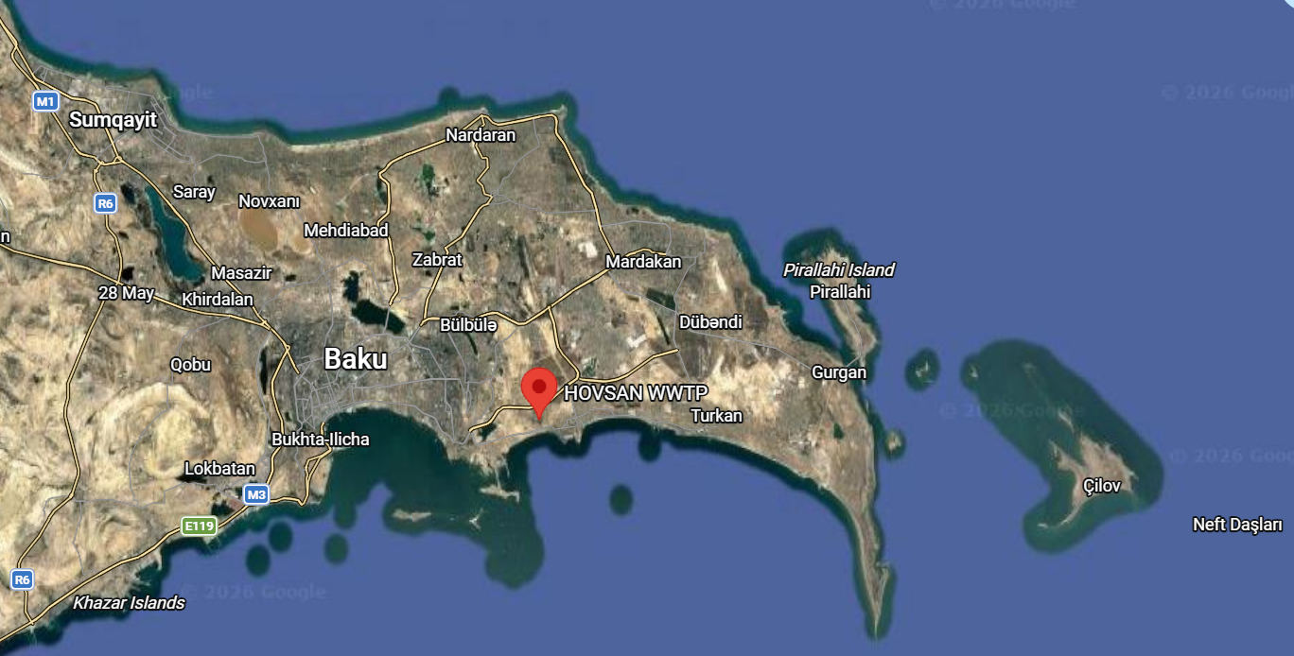

Figure 2: Pictures of the Hovsan WWTP

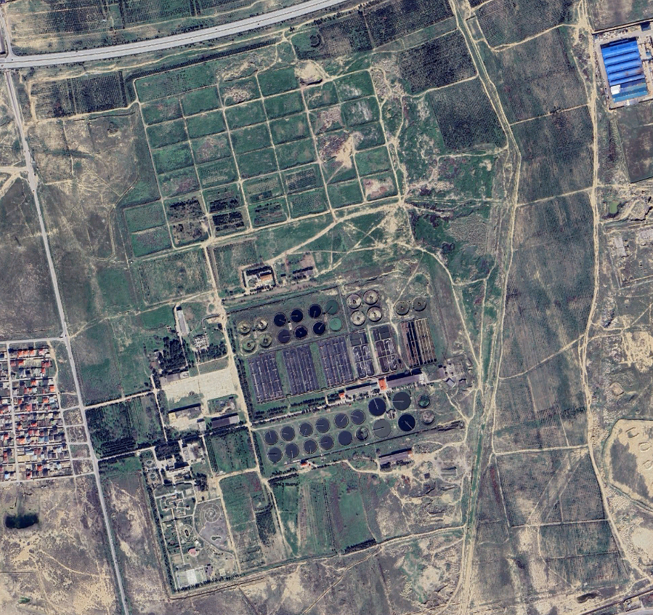
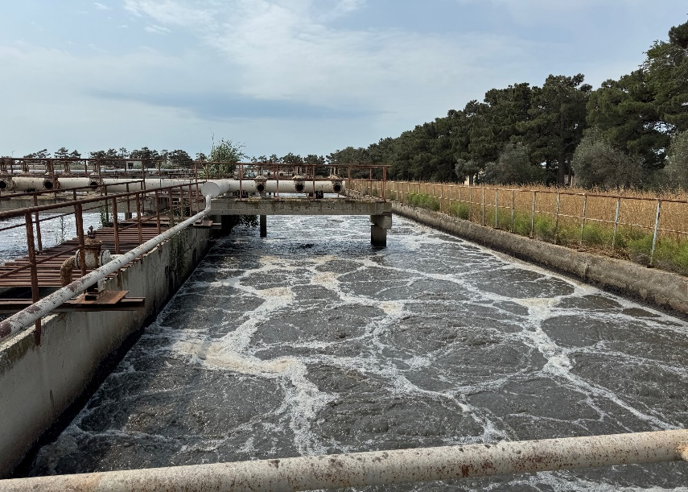
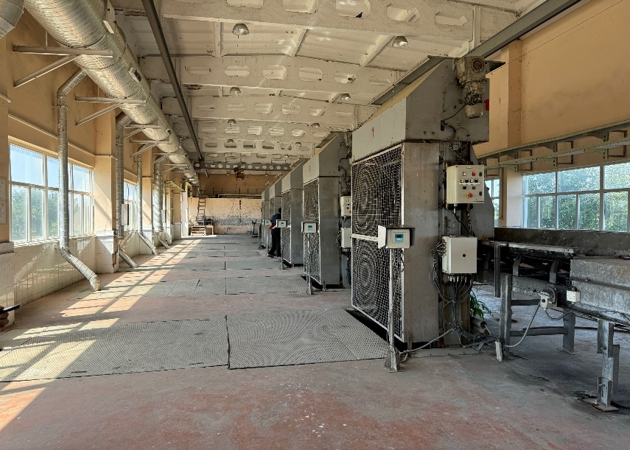
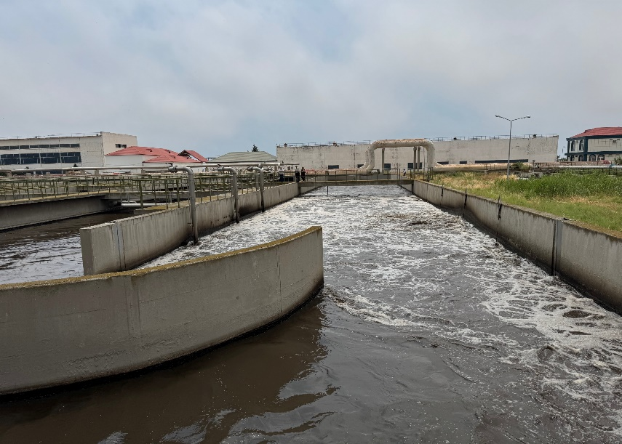
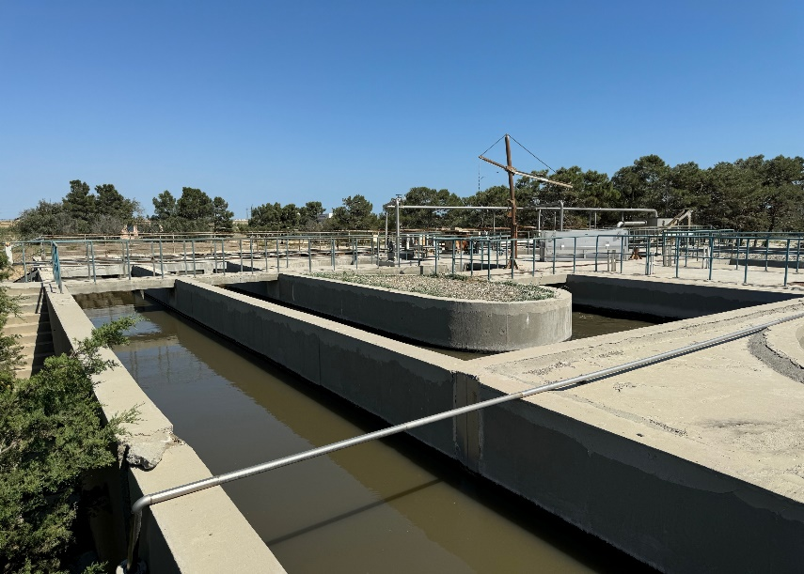

PPP Modality (Design-Build-Finance-Operate-Maintain)

- The Project will be structured under a DBFOM scheme with a balanced allocation of risks to ensure bankability. For example, no demand/volume risk (of wastewater treatment and recycled water supply) will be allocated to the Private Partner, land rights will be secured by the GOA and provided to the Private Partner, GOA will commit on volumes and quality of influents etc.

- The payment mechanism for the Project will be designed to fully cover the Private Partner's fixed and variable operating costs (including electricity costs) and capital costs respectively, subject to performance penalties.

Figure 3: Simplified Project Contractual Structure (Indicative)

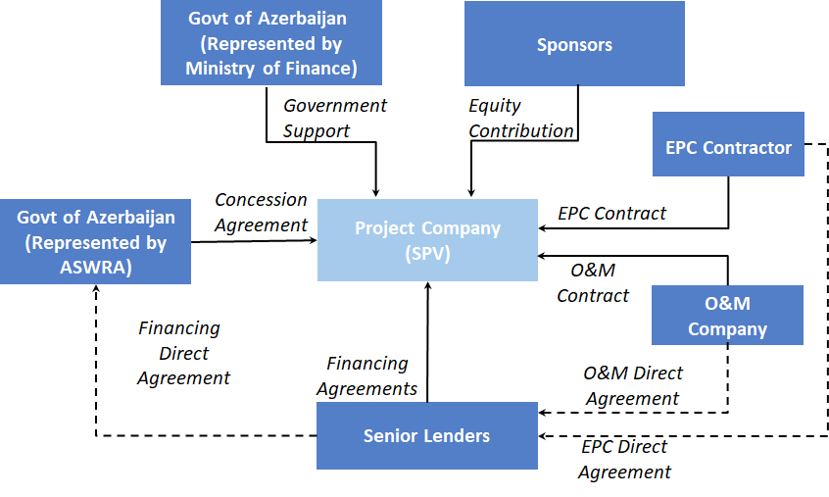
Note: The Government Support for the Project may be in line with the precedent transactions
in the Republic, which will be further detailed at later stages.

- The Project is ideal for procurement through PPP modality for various reasons:

    - National priority for essential social service provision: The Project is a national strategic priority and GOA highly values innovation and efficiency to be brought by the Private Partner for improved social service provision.

    - Government commitment: GOA is committed to implement the Project with well-balanced risk allocation (e.g. offtake commitment) in support of the private sector participation.

    - Enabling PPP environment: GOA actively promotes PPPs as per national development strategies and offers well established legislative frameworks practiced by GOA institutions.

    - Demonstrated PPP track record of Procurement Authorities: ASWRA and MOE hold institutional experience in PPP procurement, having successfully tendered the 300,000 m³/day seawater desalination PPP project.

    - Pipeline of privately-financed infrastructure PPPs: GOA has successfully executed several large-scale infrastructure PPPs (e.g. the seawater desalination plant (above), 100 MW Gobustan Solar Project, 240 MW Khizi-Absheron Wind Project, among others) which well attracted private sector investments. This evidences the market’s strong investment appetite for infrastructure PPPs in the Republic.
Indicative Timeline

Milestone | Expected Date
EOI launch | [●July 2026]
EOI submissions by interested parties | [●August 2026]
RFQ launch | [●September 2026]
RFQ submissions | [●November 2026]
RFP launch | [●December 2026]
RFP submissions | [●April 2027]
Preferred bidder announcement | [●June 2027]
PPP contract signing | [●August 2027]

Note: Indicative Timeline may be updated during the tender process as per GOA’s discretion.

Country Information – Republic of Azerbaijan

- The Republic of Azerbaijan is a country of rich cultural, artistic and archaeological heritage that is strategically located at the crossroads of Eastern Europe and Western Asia. It is bordered by the Caspian Sea to the east, Russia to the north, Georgia to the northwest, Armenia to the west, and Iran to the south. It is also the largest country in the South Caucasus, with a population of approximately 10.5 million, almost half of whom reside in around its capital and largest city, Baku.

- The Republic is an upper-middle-income country having investment grade sovereign credit ratings, Fitch BBB- Stable (June 2026) and Moody's Baa3 Positive (July 2025), reflecting the nation's robust balance sheet, low government debt, and sustained macroeconomic and institutional reforms.

- The GOA’s long-term development vision is set out in the "Azerbaijan 2030: National Priorities for Socio-Economic Development" and the “2022-2026 Socio-Economic Development Strategy”, which focus on strengthening economic competitiveness, improving public sector efficiency, promoting environmental sustainability, and accelerating private investment in infrastructure.

- Although endowed with abundant oil and natural gas reserves which integrated the Republic into global energy supply chains, and led to great prosperity since the mid-2000s, the country is actively investing in new sources of growth and jobs, such as tourism, trade and logistics, renewable energy and digitalization.

Table 4: Key Economic Indicators

Indicator | 2021 | 2022 | 2023 | 2024 | 2025
Total GDP (billion current $) | 54.8 | 78.8 | 72.4 | 74.4 | 75.9
GDP per capita (current $) | 5,458.2 | 7,806.4 | 7,133.0 | 7,294.6 | 7,413.1
GDP non-oil/gas (% of GDP) | 62 | 52 | 64 | 68 | 72
Budget Revenue (% of GDP) | 28.3 | 22.9 | 28.6 | 29.4 | 30.3
Tax Revenue (% of GDP) | 9.2 | 11.6 | 13.1 | 12.5 | 12.7
Fiscal balance (% of GDP) | (1.1) | (1.0) | (1.0) | (0.4) | 0.4
Unemployment rate (%) | 6.0 | 5.6 | 5.5 | 5.3 | 5.2
Total external debt (% of GDP) | 14.8 | 8.5 | 8.9 | 6.9 | 6.3
Central Bank’s FX reserves (in months of merchandise imports) | 7.3 | 7.4 | 8.1 | 6.3 | 5.7
Central Bank Reserves (billion $) | 7.1 | 9.0 | 11.6 | 11.0 | 11.5
Sovereign wealth fund reserves (billion $) | 45.0 | 49.0 | 56.1 | 60.0 | 73.5
Average exchange rate (AZN/US dollar) | 1.700 | 1.700 | 1.700 | 1.700 | 1.700
Source: State Statistical Committee (www.stat.gov.az), Central Bank of Azerbaijan (www.cbar.az) , Ministry of Finance (www.maliyye.gov.az), World Bank (https://data.worldbank.org)

Contacts

Completed EOIs (as per the response form attached) must be submitted electronically no later than 14th August 2026 to ppp@economy.gov.az

- Azerbaijan State Water Resources Agency (ASWRA) – Orkhan Hamidli
Email: [orkhan.hamidli@adsea.gov.az]

- Ministry of Economy of the Republic Azerbaijan (MOE) – Amrah Garayev
Email: [amrah.qarayev@economy.gov.az]

- Asian Development Bank
Email: hovsanwwtp@adb.org

